|  |  |  |
| --- | --- | --- |
| **COMP1797 (2020/21)** | **Wireless and Mobile Technologies** | **Contribution: 50% of course** |
| **Course Leader: Dr Ivana Tomic** | **Coursework 1** | **Deadline Date: Friday 12/03/2021** |

|  |
| --- |
| Plagiarism is presenting somebody else's work as your own. It includes copying information directly from the Web or books without referencing the material; submitting joint coursework as an individual effort; copying another student's coursework; stealing coursework from another student and submitting it as your own work.  Suspected plagiarism will be investigated and if found to have occurred will be dealt with according to the procedures set down by the University. Please see your student handbook for further details of what is/isn't plagiarism.  **All material copied or amended from any source (e.g. internet, books) must be referenced correctly according to the Harvard reference style.**  **Your work will be submitted for plagiarism checking.  Any attempt to bypass our plagiarism detection systems will be treated as a severe Assessment Offence.** |

#### Coursework Submission Requirements

* An electronic copy of your work for this coursework must be fully uploaded on the Deadline Date of **Friday 12/03/2021** using the link on the coursework Moodle page for COMP1797.
* For this coursework you must submit a single PDF document.  In general, any text in the document must not be an image (i.e. must not be scanned) and would normally be generated from other documents (e.g. MS Office using "Save As .. PDF"). An exception to this is hand written mathematical notation, but when scanning do ensure the file size is not excessive.
* There are limits on the file size (see the relevant course Moodle page).
* Make sure that any files you upload are virus-free and not protected by a password or corrupted otherwise they will be treated as null submissions.
* Your work will not be printed in colour. Please ensure that any pages with colour are acceptable when printed in Black and White.
* You must NOT submit a paper copy of this coursework.
* All courseworks must be submitted as above. Under no circumstances can they be accepted by academic staff.

The University website has details of the current Coursework Regulations, including details of penalties for late submission, procedures for Extenuating Circumstances, and penalties for Assessment Offences.  See <http://www2.gre.ac.uk/current-students/regs>

**_______________________________________________________________________________**

**DETAILED SPECIFICATION**

**Mini-project: Produce a simulation-based five-page double-column paper on an advanced topic of your choice that is related to the content of the course.**

This is a group coursework. You need to form groups of up to two members. One is allowed, but three is not.

Some representative areas that you can choose your topic from are:

a) Smart home/building (or any other Internet of Things setup)

b) Communications of emergency response/disaster management

c) Cyber-physical systems

d) Wireless sensor network systems

e) If you are not happy with any of the above, you can request your tutor to approve an alternative area of your choice.

You need to select an area where you can run meaningful simulations, using a simulation method of your choice. Alternatively, if you have the equipment and time required you can conduct real experiments rather than simulations. In either case, choose two performance metrics based on which you will evaluate different network configurations and present your results in the form of a paper. You will be asked to look into the security aspect of a chosen configuration.

**DELIVERABLES**

The final output is a **five-page** **double-column paper** according to the template (loosely based on the IEEE paper format), which can be seen on the next page. There is a 20% penalty if the report does not abide by the rule of a length of strictly 5 pages, following precisely the template.

To receive a mark, you need to demonstrate your work. The demonstration will be arranged by your lecturer.Title (e.g. Evaluation of different network configurations in the area of …..)

Author 1 name and author 2 name

MSC in *…*

COMP1797: Wireless and Mobile Technologies

University of Greenwich

Old Royal Naval College

United Kingdom

*Abstract*—This is a very brief summary of the work produced, including a brief explanation of the topic, simulation mechanism and key results. This is the first piece of text that the reader will see. So, make sure it is well-written. A good length is one or two paragraphs (not more than 150 words).

The Abstract is worth 10% of the report.

Key words: (keyword 1, keyword 2, keyword 3, keyword 4; choose four relevant keywords or terms that characterize the topic of your choice)

# Introduction

Here, you describe the motivation and rationale behind the specific topic. What makes the particular area interesting or important, where is it used in the real world, and why does it make sense to measure the particular performance metrics that you have chosen. Use this space to set the scene for the rest of your paper.

Note that it is important to follow this template from the beginning to the end. Do not change fonts (Times New Roman 11), sizes or anything else.

Unlike the next section (related work), it is OK here to cite non-academic publications, such as relevant announcements from the government, news items etc.

**The introduction is worth 5% of the report.**

Note that the whole paper needs to be precisely 5 pages. If you exceed the 5-page limit you will lose marks.

# Related work

Also known as “literature review”, this is among the most important aspects of the paper. Here, you need to briefly review academic papers that have been published in the same area and specifically on the same topic. If you cannot find exactly the same topic, focus on papers that are as close as possible.

A good “related work” section is based on only reputable sources from highly cited academic publications. It is generally safe to cite IEEE, ACM, BCS, Elsevier and Springer papers or papers that have at least five citations. Use Google Scholar to perform your research. Not only it speeds up the process, but also it shows the number of citations of each paper.

Although there is no strict limit to the number of papers expected to be discussed in this section, a good recommendation is to have at the very least four but try for several more.

Contrary to IEEE, ACM and most other publishers of academic papers in computer science, our university requires the Harvard style of referencing to be followed. Make sure you know what this is and adapt your style of writing accordingly. For instance, a common way to discuss related papers is as follows:

Surname et al. (2014) have conducted a performance evaluation of different … with regards to network jitter, energy efficiency and …. With the use of twenty NS-2 simulation runs for its experiment, they have concluded that the … has considerably lower … than …. However, it achieves this at the expense of a higher … in the following situations … The particular tradeoffs have also been researched by Other Surname et al. (2012), specifically for the case of ….

And so on…

**The related work section is worth 20% of the report.**

# Simulation environment

Here, you start by describing the simulation tools that you used and why they are suitable for a particular topic. Then, you describe in good detail the scenario (the configuration of the simulations/experiments that you conducted for a particular application) including an image (see Figure 1) that shows the network topology or any other important information regarding the scenario.

**This section is worth 15% of the report.**

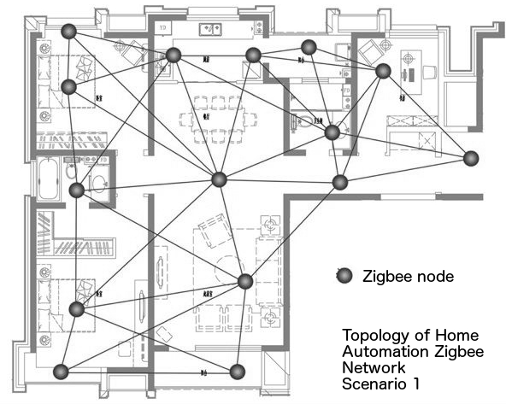

Figure 1. Topology of the Zigbee network of scenario 1.

# Results

Provide two figures summarising the numerical results. Make sure you run several runs for each scenario/configuration and record the average results. Explain them in detail. This is the whole point of this paper. So, put sufficient effort not only in running the experiments, but also in explaining the results and how they compare to any related experiments mentioned in the “related work” section.

Ensure that your graphs are presentable. Most people produce graphs on Matlab or Excel. Make sure they are not fuzzy or have distorted dimensions or tiny fonts that cannot be read etc. Also, they should not be in colour because papers are printed in black & white. Make sure that a reader seeing it in black & white can tell which curve is which. Also, make sure that you have labels and units of measurements on both axes, and that you include a caption below each figure. Example figures can be seen in Figure 1 and Figure 2.

Discussion can be as follows:

In the first configuration, where the … is set to a low value of …, we observe that the … increases rapidly as the … increases (see Figure 2). However, this is not the case when we change … (see Figure 3). This is in accordance with the work carried out previously by … (cite in Harvard style …).

And so on …

**This section is worth 30% of the report.**

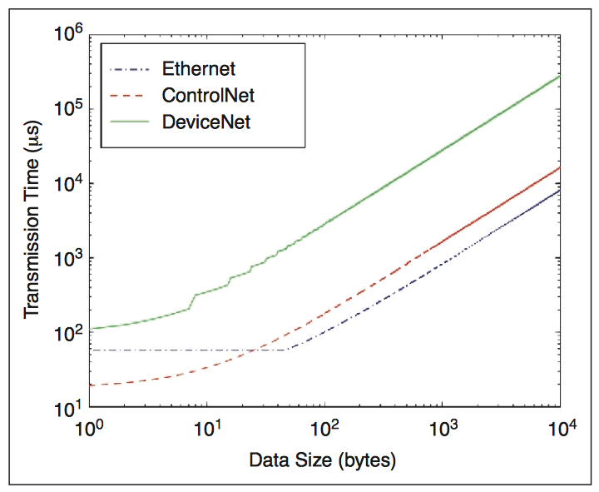

Figure 2. Evaluation of Ethernet, ControlNet and DeviceNet in terms of Transmission Time.

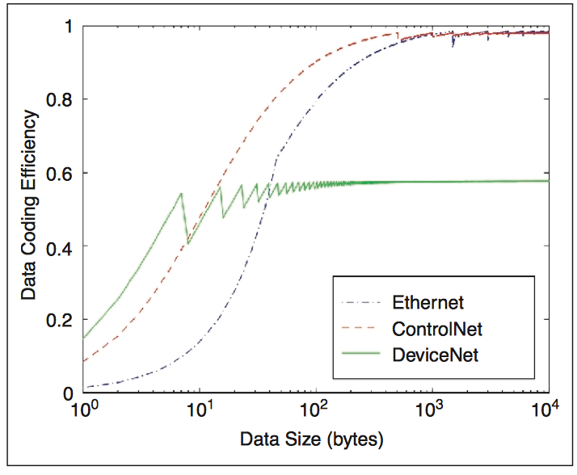

Figure 3. Evaluation of Ethernet, ControlNet and DeviceNet in terms of Data Coding Efficiency.

# Security Challenges

Here for the proposed configuration, define and explain one potential security threat. Explain what negative effects it could have on the network performance. You can refer to the existing literature (no need to invent attacks). Also, list the potential countermeasures that could be used to protect the configuration. Make sure you refer to relevant research papers (and that you cite them properly). No need to simulate.

**The Security Challenges section is worth 10% of the report.**

# Conclusions

Here, you briefly summarise the work carried out and suggest possible future work. The conclusions section is similar to the abstract with the addition of the future work suggestion or perhaps more detail in the summarization of the results of the previous section.

**The Conclusions section is worth 5% of the report.**

# Acknowledgement

This is an optional section, where, if you want, you can thank colleagues or family that helped you or supported you in relation to this particular paper.

# References

List and number all references used in this paper following the Harvard Referencing style. It is not terribly important whether in each reference you place the issue number, page, publisher etc. What matters is that you are consistent and you use precisely the same format in all your references.

An example list of references following the Harvard referencing style is shown below. Note the appropriate use of italics:

Young, H.D., Freedman, R.A., Sandin, T. and Ford, A. (2000) *Sears and Zemansky's university physics*. 10th edn. San Francisco: Addison-Wesley.

Bell, J. (2005) *Doing your research project*. 4th edn. Maidenhead: Open University Press.

Jackson, G. (2000) 'Ports 1700-1840', in Clark, P. (ed.) *Cambridge urban history of Britain: Vol. 2 1540-1840*. Cambridge: Cambridge University Press, pp.705-731.

Cook, D. (2000) 'Developing franchised business in Scotland', *Small firms: adding the spark: the 23rd ISBA national small firms policy and research conference*. Robert Gordon University, Aberdeen 15-17 November. Leeds: Institute for Small Business Affairs, pp. 127-136.

**The list of references is worth 5% of the report.**

**ASSESSMENT CRITERIA**

The precise marking scheme is included within the template of the paper and is repeated here for clarity:

**Abstract 10%** - Provide a brief explanation of the topic, work that will be undertaken including simulation mechanisms, and key results that are expected o be achieved.

**Introduction 5%** - Provide the motivation and rationale behind the specific topic. What makes the particular area interesting or important, where is it used in the real world, and why does it make sense to measure the particular performance metrics that you have chosen.

**Related work 20%** - Provide a brief review of the academic papers that have been published in the same area and specifically on the same topic.

**Simulation environment 15%** - Provide a discussion of different simulation tools has been carried out to provide reasoning for choosing the simulation tool(s) and why these are suitable for the particular topic. Provide a description of the scenario (the configuration of the simulations/experiments that have been conducted for a particular application) including an image of the network topology or any other important information regarding the scenario.

**Results 30%** - Present two figures that summarise numerical results. The quality of figures is important (dimensions, labels, caption, etc.). Explain the figures in details and critically discuss the results with regards to the question(s) that the research study attempts to answer.

**Security Challenges 10%** - For the proposed configuration, provide one potential security threat. Explain its effects and potential countermeasure.

**Conclusions 5%** - Provide a brief summary of the work that has been carried, as well as critical results and a discussion of possible future work.

**References 5%** - Provide appropriate listing and numbering of all references used in this paper (journal papers, conference papers, academic books) following the Harvard Referencing style have been provided. The quality and relevance of the included resources and their suitability to support the writing are important.

There is a 20% penalty if the report does not abide by the rule of a length of strictly 5 pages, following precisely the template.

|  |  |  |  |  |  |  |  |
| --- | --- | --- | --- | --- | --- | --- | --- |
| **Criteria for Assessment** | **90-100**  **Exceptional** | **80-89**  **Excellent** | **70-79**  **Very Good** | **60-69**  **Good** | **50-59**  **Satisfactory** | **30-49**  **Fail** | **0-29**  **Fail** |
| **Assessment domain 1**  Demonstrate a critical understanding of the technical challenges posed by current mobile systems and wireless communications. | Demonstrates an exceptional systematic understanding of Mobile and Wireless Network Technologies and their technical challenges. The motivation and rationale of a chosen area is underpinned by an exceptional understanding of relevant theory and best practices and engagement with the literature. | Demonstrates an excellent systematic understanding of Mobile and Wireless Network Technologies and their technical challenges. The motivation and rationale of a chosen area are underpinned by an excellent understanding of relevant theory and best practices and engagement with the literature. | Demonstrates a very good understanding of Mobile and Wireless Network Technologies and their technical challenges. There is evidence that relevant theory and best practices have been applied effectively in the choice of area, and there is the engagement with the literature. | Demonstrates overall a good understanding of Mobile and Wireless Network Technologies and their technical challenges. There is some evidence that relevant theory and best practices have been applied effectively in the choice of area, and there is some engagement with the literature. | There is satisfactory evidence that at least some Mobile and Wireless Network Technologies and practices have been applied and supported by the literature. | There is a lack of understanding of Mobile and Wireless Network Technologies and their technical challenges. The choice of the research problem lacks justifications and is not supported by the literature. | There is hardly any engagement with relevant technologies, technical challenges and best practices. The choice of the research problem is not based on engagement with the literature. |
| **Assessment domain 2**  Understand and evaluate the performance, costs, overheads and trade-offs of different wireless and mobile communication technologies. | The assignment provides exceptionally strong and consistent evidence of critical evaluation when considering the adequately chosen performance metrics, cost, overhead and trade-offs of the used technologies. The results of the analysis have been clearly presented in accordance with the provided guideline. | The assignment provides excellent evidence of critical evaluation when considering the adequately chosen performance metrics, cost, overhead and trade-offs of the used technologies. The results of the analysis have been clearly presented in accordance with the provided guideline. | The assignment provides very good evidence of critical evaluation when considering the chosen performance metrics, cost, overhead and trade-offs of the used technologies. The results of the analysis have been presented in accordance with the provided guideline. | The assignment provides some good evidence of critical evaluation when considering the chosen performance metrics, cost, overhead and trade-offs of the used technologies. The results of the analysis have been presented mostly in accordance with the provided guideline. | There is some evidence of evaluation with respect to performance metrics, cost, overhead and trade-offs of the used technologies. The analysis is not very conclusive. Satisfactory presentation of  the results. | The assignment provides little evidence of evaluation with respect to performance metrics, cost, overhead and trade-offs of the used technologies. Not satisfactory presentation of  the results. | The assignment lacks evidence of evaluation with respect to performance metrics, cost, overhead and trade-offs of the used technologies. No  results have been provided. |
| **Assessment domain 3**  Be able to evaluate available technologies for the design and implementation of mobile and wireless networks according to user requirements. | Demonstrates an exceptional systematic understanding of mobile and wireless network design processes based on user requirements. The understanding is supported by extensive literature. | Demonstrates an excellent systematic understanding of mobile and wireless network design processes based on user requirements. The understanding is supported by extensive literature. | Demonstrates a very good understanding of mobile and wireless network design processes based on user requirements. The understanding is supported by the appropriate literature. | Demonstrates overall a good understanding of mobile and wireless network design processes based on the user requirements. The understanding is supported by some literature. | There is satisfactory evidence that at least some user requirements have been considered in mobile and wireless network design processes and is supported by some literature. | There is a lack of understanding of mobile and wireless network design processes based on user requirements. No evidence of supporting literature. | There is hardly any engagement with an understanding of mobile and wireless network design processes based on user requirements. No evidence of supporting literature. |
| **Assessment domain 4**  Be able to understand and evaluate the key security threats that relate to different mobile and network technologies, as well as appropriate countermeasures. | The assignment provides exceptionally strong and consistent evidence of critical evaluation when considering the security vulnerability or vulnerabilities of the chosen configuration and the appropriate countermeasures. The understanding is supported by extensive literature. | The assignment provides excellent evidence of critical evaluation when considering the security vulnerability or vulnerabilities of the chosen configuration and the appropriate countermeasures. The understanding is supported by extensive literature. | The assignment provides very good evidence of critical evaluation when considering the security vulnerability or vulnerabilities of the chosen configuration and the appropriate countermeasures. The understanding is supported by the appropriate literature. | The assignment provides some good evidence of critical evaluation when considering the security vulnerability or vulnerabilities of the chosen configuration and the appropriate countermeasures. The understanding is supported by some literature. | There is some evidence that at least some of the security aspects of the chosen configuration have been considered. The understanding is supported by some literature. | There is a lack of understanding of the security aspects of the chosen configuration. No evidence of supporting literature. | There is hardly any engagement with understanding the security aspects of the chosen configuration. No evidence of supporting literature. |